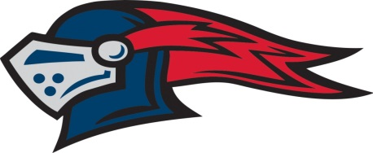
UNIVERSITY LIGGETT SCHOOL
VARSITY TENNIS ROSTER
FALL 2021

Name Year
George Anusbigian 2023
Brendan Connors 2022
Charles Cooksey 2025
Sebastian Courtright 2024
Bennett French 2022
Ryan King 2023
Campbell Marchal 2023
Luca Muller 2024
Neil Murphyl 2023
Bode Neumeister 2022
Gerald (Gerry) Sherer 2023
Jacob Tomlinson 2022
Thomas (Tommy) Ugval 2024
Stephen (Stevie) Wheatley 2023
Head Coach: Mark Sobieralski Assistant Coach: Lauren Harris
Athletic Staff: Alan Parish, AD; Michelle Hicks, Ast. AD; Erin Raymond, Trainer
Administration: Bart Bronk, Head of School; Shernaz Minwalla, Head of Upper School; Matt Lapolla, Asst. Head of Upper School ; Kelley Hamilton, Associate Head of School/Chief Operating Officer

