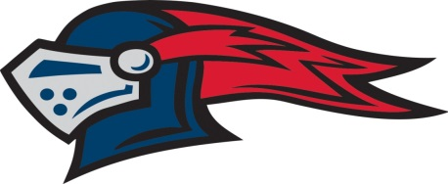
UNIVERSITY LIGGETT SCHOOL
VARSITY SWIM ROSTER
FALL 2021

Name Year
Addie Ancona 2025
Kelsey Beckett 2024
Emilia Bronk 2022
Mikaila Farah 2023
Isabella Haladjian 2024
Sophia Herman 2022
McMahon, Ginger 2022
Victoria Roth 2022
Wheatley, Hannah 2022
Head Coach: Chris Cornell Assistant Coach: Elisa Cornell
Athletic Staff: Alan Parish, AD; Michelle Hicks, Asst. AD; Erin Raymond, Trainer
Administration: Bart Bronk, Head of School; Shernaz Minwalla, Head of Upper School; Matt Lapolla, Asst. Head of Upper School; Kelley Hamilton, Associate Head of School/Chief Operating Officer

